**Modular Intrusion Prevention System**

Rajendra Kumar Raghupatruni**,** Ravi Chandra Sadineni

Harshavardhan chowdary Ellanti, Nitish Garg**,** Anshul Anshul

Stony Brook University

## Abstract

Intrusion Prevention Systems are part of the defense-in-depth strategy of computing systems. One popular Intrusion Prevention System is called *fail2ban*. *Fail2ban* monitors failed authentication attempts and temporarily blocks traffic from IP addresses that exceed a configurable number. e.g. fail2ban can block all traffic from IP address 1.2.3.4 if that IP address tried to log in more than 10 times in one minute. Our application is similar to fail2ban in a way it monitors auth.log, errors.log etc., to identify the ip/hosts which tries to re-login multiple times within a short span of time. Upon identifying those IP address which reaches the threshold retries during the configured time window, they are blocked for a configurable period of time thus reducing the likelihood of successful dictionary attacks. Moreover, this application can be configured to support any application(s) that captures the authentication failures to the log, thereby avoiding the burst login retries from a client.

## Introduction

Intrusion Prevention Systems are security appliances that monitor systems for malicious activities. These systems identify malicious activities based on the log information, block the actions/traffic and report it. *Fail2ban* is one such application monitor that monitors the authentication attempts and temporarily blocks traffic from the corresponding clients based on the threshold number of retries during a particular time window. The current implementation is similar to fail2ban like monitor that monitors applications like SSH, phpMyadmin, Joomla and Wordpress. Modular Intrusion Prevention System(MIPS) monitors the authentication failure logs and keeps track of all such events from the client IP address. When the number of failure attempts reach a certain threshold for some configurable duration of time, the traffic from the corresponding IP is blocked at the server. Since blocking indefinitely will cause a complete Denial of Service for the client, the block is only done for a certain configurable period of time. All the configurable parameters can be initialized or modified from the admin console.  The admin console also provides the flexibility to unblock the IPs of interest. So when a legitimate user fails to enter the correct password many times, he can still get it unblocked by consulting the administrator.

Though this application doesn’t completely eliminate all the security attacks like brute force attacks and dictionary attacks, it makes these attacks harder to perform and take very long periods of time in order to achieve the objective of the attacker. Moreover, the current implementation supports as many applications as possible based on a configuration file, thus eliminating the need to rewrite the whole implementation for new application panels.

Section 2 describes the design and implementation of an intrusion prevention system. Section 3 describes the evaluation which includes the experimental setup and how they are configured per application. Section 4 presents the results of these experiments along with their screenshots. Section 5 is the conclusion. Section 6 includes future work.

## Design and Implementation

Intrusion Prevention System utility monitors the auth.log and error.log to identify failure login attempts from a client IP address. The implementation of this utility is based on the below identified tasks.

* The logs need to be parsed to identify a login failure.
* Upon threshold number of unsuccessful retries, the client IP should be blocked.
* The blocked IPs should appear in the admin console.
* The clients which are blocked should not be able to access the server for a configured period of time.
* The administrator should be able to remove/unblock IP addresses from the blocked list.
* The number of unsuccessful attempts, the time and blocking period should be configurable (only by the administrator).

**Components:**

The major components (as indicated in Figure 3) of the system are the applications, log files, admin interface, Postgres database, system iptables and the central Modular Intrusion Prevention System.

* **Admin Interface**: An admin interface provides an option to view and remove IP addresses from the blocked list. The administrator can also configure the threshold retries, time interval for which the requests are monitored, and the time interval for which an IP address has to be blocked. This user interface is built in python using Django framework. It communicates with PostgreSQL database which holds tables for storing the configuration and blocked IPs information. Details on the database schema are provided below. Note that user interface does not communicate directly with the Intrusion Prevention System. It only communicates with the database. Thus both these applications run independently.

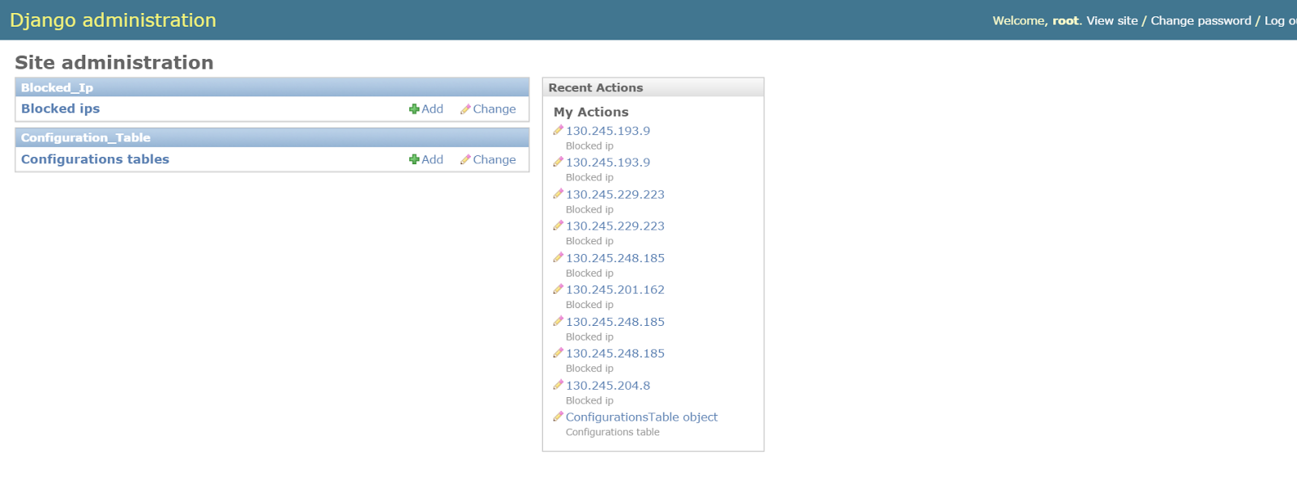

Figure 1: Admin Interface to manage the blocked client IP addresses and configuration parameters.

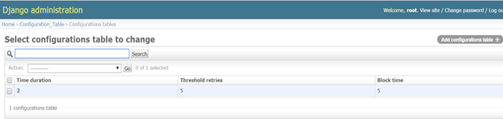

Figure 2: Configuration parameters

* **Database:** Database acts as a persistent storage of the current state as well as a communication layer between the admin interface and the Intrusion Prevention System. There are three main tables, *blocked_ip*, *configuration_table*, and *ip_hits* used for the bookkeeping in the system. Admin interface communicates with the database using the Django ORM. Intrusion Prevention System uses an open source library, [SQLAlchemy](http://www.sqlalchemy.org/) and a python driver, [pyscopg2](http://initd.org/psycopg/) for communicating with the PostgreSQL. A single application layer session is maintained and every write to the database is committed atomically to prevent database inconsistencies. Each of these tables are discussed below in detail.

1. Configuration table

|  |  |  |
| --- | --- | --- |
| time_duration: int | threshold_retries: int | block_time: int |

    Table 1: Columns of *configuration_table* table

Configuration table holds all the fields that can be configured by the admin.

* *time_duration* represents the minutes prior to the current time for which the entries of *ip_hits* are considered while counting the retries.
* *threshold_retries* is the maximum number of acceptable retries. If there are more than *threshold_retries* in the last *time_duration* minutes, then the IP is added to the *blocked_ip* table.
* *block_time* indicates the number of minutes the traffic from this particular IP has to be blocked.

The reason for holding these values in the database instead of a configuration file is to allow the admin to edit these values dynamically. The application reads these value from the database whenever needed. This way, they are immediately reflected once the admin re-configures them.

2. Ip_hits table

|  |  |
| --- | --- |
| client_ip: Char | hit_time : Date_time |

    Table 2: Columns of *ip_hits* table

*ip_hits* table holds all the failed login attempts. On a failed login attempt to any of the above mentioned applications, the client IP and the current time tuple is inserted into the table. The application then scans the table to see if there are *threshold_retries* number of entries from the same *IP* in the last *time_duration* minutes*.*  Note that the *threshold_retries* and *time_duration* are read from the *configuration_table*.  If there are more than threshold entries, then an entry is made into the *blocked_ip* table. Along with the entry into the *ip_hits* table, an entry is also made in the *System IP table*.  *System IP table* acts like a firewall and blocks all the packets originating from that particular source. Once an entry is made into these two tables, *ip_hits* table is invalidated by deleting all the entries from this source.  Also periodically this table is cleaned by removing all the old entries which are of no significance thereby maintaining the number of table entries small.

3. Blocked_ip table

|  |  |  |
| --- | --- | --- |
| client_ip : Char | block_start : Date Time | force_remove : boolean |

    Table 3: Columns of *blocked_ip* table

*blocked_ip* table holds the list of the *IP* addressesthat are currently blocked along with the time at which they are blocked.  The entry into this table is triggered by a failed login entry as discussed above. This table is periodically scanned for entries that are blocked for configured block time, upon the expiry of the block time period the *IP* is unblocked. All the entries are removed periodically from the table once the *IP* is unblocked. When removing the entry from *blocked_ip* table, it is also purged from the *System* *IP table* thus allowing the traffic from this particular source.  Additionally a field, *force_remove* is provided for the admin to unblock *IP*’s of interest. If admin marks this field to *true* for a particular entry, then the entry is immediately removed irrespective of the time at which the entry is made. This way admin can re allow traffic from a blocked *IP*.

* **Intrusion Prevention System:** This is the main module of the system and is responsible to manage the flow of traffic in the system. It consists of work queue and various threads interacting with database, log files and with each other. The purpose of each of them is explained in workflow section below.

**Workflow**

The workflow (as indicated in Figure 4) consists of a work queue, multiple producer threads (one per application), a single consumer thread and a single unblocking thread. Each producer thread polls a log file for any event of failed login. On a failed login event, this thread adds the parsed IP address into a work queue*. Consumer thread dequeues the IP addresses from the queue and inserts those addresses into the *ip_hits* table. Also, at the same time it runs an SQL query that checks if there are more than threshold login attempts from the same IP address in the specified time interval. If there are threshold login attempts, they are removed from the table *ip_hits* and a single entry is made into the *blocked_ip* table as well as the *System IP table*. Note that an entry into the *System IP table* will actually block the incoming traffic from that address (like a firewall). The Admin console displays these *blocked_ip* table entries for managing the blocked IP addresses. The Unblock thread checks the *blocked_ip* table and *configuration_table* for any IP address that have been blocked for the *block_time* minutes and then removes the entries from both *blocked_ip* table and *System IP table*. And it is also responsible for allowing the traffic from the IP address.

Note: *Queue in python is a synchronized class where the information can be exchanged safely among multiple threads without explicit locking mechanism.

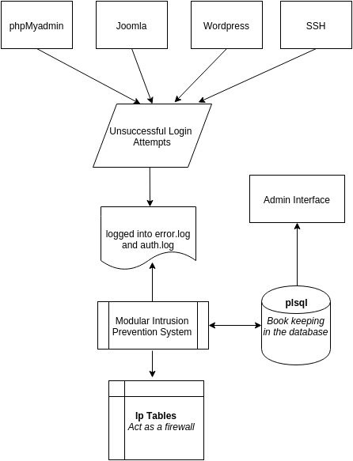

Figure 3: Block diagram of the Intrusion Prevention System

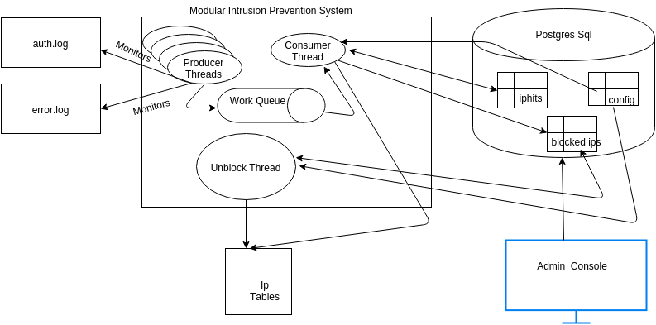

Figure 4: Modular Intrusion Prevention System

## Evaluation

**Experimental Setup**

We conducted experiments on a Google Cloud node running on an Intel(R) Xeon(R) CPU @ 2.30GHz with 3GB main memory. The machine runs Linux kernel 3.16. We installed Python 2.7, Apache2, phpMyadmin, MySQL, Joomla and Wordpress on the machine. We used Django framework to build web interface for the administrator to update the threshold parameters. We installed PostgreSQL for bookkeeping and state management of the applications login failure attempts.

Since Joomla, phpMyadmin, Wordpress don’t directly log the authentication issues to a log file, we need to explicitly modify the source code for these web applications to force write to the log files. Each of these are indicated clearly in the individual experiments.

**Experiment 1: Joomla Admin Console Monitoring**

**Setup**

Installation of Joomla can be done through the ***preInstall.sh*** utility which is a part of the source code bundle. Since Joomla doesn’t log the authentication failures, below setup is required in-order to log the login failures from an IP address.

|  |
| --- |
| *cd <Intrusion Prevention Setup Directory>*  *cd joomla*  *cp php.ini /etc/php5/apache2/php.ini*  Note: Make sure the value of error_log in the above configuration is present and has write permissions for the application to write logs to it.  *cp admin/controller.php /var/www/joomla/administrator/components/com_login/controller.php*  Note: In-order to allow user logins also to be monitored, execute the below  *cp user/user.php /var/www/joomla/components/com_users/controllers/user.php*  *sudo service apache2 restart* |

The above setup ensures the login failures are logged as below.

|  |
| --- |
| *[18-Nov-2015 00:13:03 UTC] ERROR: joomla Login failed for the user: root, from 130.245.192.170* |

Login for Joomla:

|  |
| --- |
| <http://104.196.46.6/joomla/administrator/> |

**Experiment 2: PhpMyAdmin Console Monitoring**

**Setup**

Installation of PhpMyAdmin can be done through the ***preInstall.sh*** utility which is a part of the source code bundle. Since phpMyadmin doesn’t log the authentication failures, below setup is required in-order to log the login failures from an IP address.

|  |
| --- |
| *cd <Intrusion Prevention Setup Directory>*  *cd phpmyadmin*  *cp cookie.auth.lib.php /usr/share/phpmyadmin/libraries/auth/cookie.auth.lib.php*  Note: Make sure the value of error_log in the above configuration is present and has write permissions for the application to write logs to it.  *sudo service apache2 restart* |

The above setup ensures the login failures are logged as below.

|  |
| --- |
| *[18-Nov-2015 00:13:03 UTC] ERROR: phpMyAdmin Login failed for the user: root, from 130.245.192.170* |

Login for phpMyAdmin:

|  |
| --- |
| [http://104.196.46.6/phpmyadmin/](http://104.196.46.6/joomla/administrator/) |

**Experiment 3: Wordpress Admin Console Monitoring**

**Setup**

Installation instructions are explained in detailed in the below table.

|  |
| --- |
| Download and unzip wordpress from [here](http://wordpress.org/download/)  Create a Database table for wordpress and a user with all the privileges to access and modify it.  Search for the file wp-config-sample.php and rename it to wp-config.php. Enter the details of Database connectivity and the user just created in the same file  Create a folder called wordpress in the /var/www/  Copy all the files in the unzipped folder to the folder just created  Now access the url  *http://yoursite.com/wordpress/* |

Since Wordpress doesn’t log the authentication failures, we installed a third party plugin called *WP fail2ban.* Note that this plugin by default will neither manage nor make entries to the system iptables, though the name suggest the same.  This plugin will only log the failed retries to the *auth.log* file. The actual blocking of the traffic is taken care by MIPS.  Steps to install a new plugin are available from the below mentioned links.

|  |
| --- |
| <https://codex.wordpress.org/Managing_Plugins> |

The above setup ensures the login failures are logged as below.

|  |
| --- |
| *Nov 19 19:57:31 inst-1 wordpress(104.196.46.6)[9210]: Authentication failure for root from 130.245.223.98* |

Login for Wordpress:

|  |
| --- |
| <http://104.196.46.6/wordpress/wp-login.php> |

**Experiment 4: SSH Authentication Monitoring**

**Setup**

Install the ssh server if there is not already installed on the server.

|  |
| --- |
| *sudo apt-get install openssh-server* |

In-case of any ssh failed login attempts, the ssh-server logs the details to *auth.log* file. The above setup ensures the login failures are logged as below.

|  |
| --- |
| *Nov 19 14:43:24 harp sshd[918]: Failed password for rraghupatrun from 104.196.46.6 port 59517 ssh2* |

**Experiments:**

We conducted experiments for functional testing of the implementation for all applications. As a part of this, we configured threshold retries as 5 for 2 mins time duration. Upon threshold retries, the client IP address should be blocked for 5 mins. On more than 5 failed login attempts, MIPS blocks the IP address thereby not allowing the client to reload or access the page for the next 5 minutes.

We also conducted experiments to unblock the IP address from the administrative panel by setting the *Force Remove* option to *True.* And the Intrusion Prevention System application successfully unblocked the IP address.

Along with the functional tests for individual applications, we ran the below tests for all the applications mentioned earlier. Current settings in the configuration table are as follows.

|  |
| --- |
| Time_Duration : 2 mins  Threshold_retries : 5  Block_time: 5 mins |

Each of these parameters are explained above in Section 2 in detail. Below are the experimental tests we conducted to ensure the correctness and completion of the design and implementation. For all these tests, when an IP is blocked all the below properties hold true.

1. Any retry after 6th attempt should be blocked and the client should not receive any responses from the server.
2. Web server should not receive further requests from the client for the next 5 minutes.
3. Any attempt after the 6th attempt should have an entry in the *blocked_ip table* and an equivalent entry in the *System IP table.*
4. And the above entries should be deleted once the block time period expires.

Case 1: This test case makes sure that the normal functionality works properly.  We made 7 consecutive attempts. The actual result matched exactly with the expected result.

Case 2: This test case makes sure that only entries in the time span of *time_duration* are considered. For an unsuccessful attempt once every 30 secs, there will only be 4 attempts in 2 mins which are not more than the threshold entries. Ideally, the IP should not be blocked. The behaviour of our implementation worked exactly as expected. We conducted this test over a time span of 10 mins.

Case 3: This test case makes sure that if a login retry is neglected at any span of time, it may still take part in the next time interval. In the first minute, 2 failure attempts are made. In the second minute another 2 failure attempts are made. And finally during the third minute, 3 attempts are made. After the 3rd attempt in the 3rd minute, the IP is successfully blocked.

## Benchmark Results

We have conducted various experiments which are explained in Section 3 and the results are as expected. The current implementation doesn’t add any overhead to the applications which are being monitored except from writing a one line log entry upon login failure. To test this, we measured the average response times by enabling logging and disabling logging of Wordpress, Joomla and phpMyadmin using Postman rest client plugin which indicates that the additional logging doesn’t add a significant overhead. We disabled our MIPS application during this experiment.

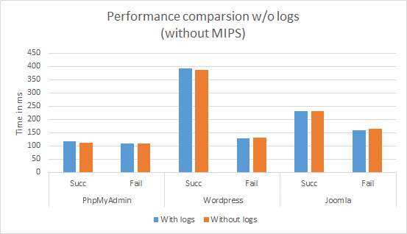

Figure 5: Performance comparison with and without logs and without MIPS.

The graph clearly shows that there is a very little overhead due to the additional logs in the failure and success scenarios. There is a maximum of 5ms overhead in both the successful and failure scenarios.

We also tested the performance of our MIPS to make sure that it is not creating any considerable performance degradation to the applications that are being monitored. The response times are measured with Postman rest client. These tests are done with MIPS enabled and disabled. The results are as shown in graph below.

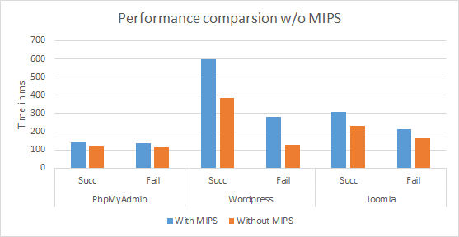

Figure 6: Performance comparison with and without MIPS.

The results clearly indicate that there is a little overhead with MIPS enabled. And even this small overhead is due to fact that our application is running on Google Cloud  virtual machine with the system configuration (1vCPU, 3GB RAM) that is too less to handle the additional threads that constantly monitor logs, do the necessary updates in the backend tables and block IPs.

We also tested the feature *Force Remove* which is introduced to help the system administrators to unblock any IP addresses of interest. This gives the administrator an additional flexibility to manage the legitimate user login failure attempts. The screenshot below shows the typical blocked IP in the admin console. We can see the *Force Remove* option present in the third column is disabled by default.

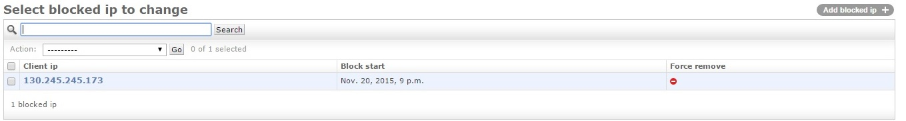

Figure 7: Force remove window.

If an administrator wants to remove the particular IP from the blocked list, then he have to select the corresponding IP and set the *Force Remove* option to *Yes*.

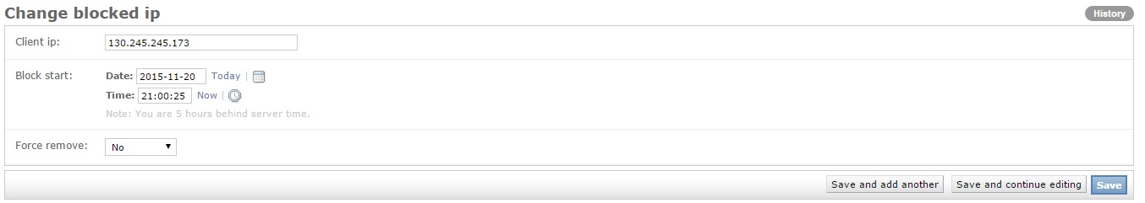

Figure 8: Administrator’s view of the blocked IP

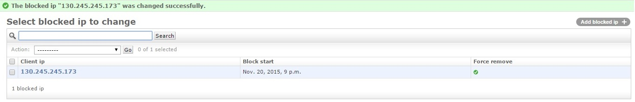

Figure 9: Successfully force removed IP

The Unblock Thread which wakes up every 10 seconds will validate the *Force Remove* field for the IP and remove the particular IP from the system iptables thus unblocks the traffic for the IP address.

## Conclusion

With the introduction of this monitor, we are able to reduce the likelihood of successful dictionary and brute force attacks. This monitor provides the flexibility to scale up to many web applications by just adding an entry to the configuration file and restart the application. Our application even provides an admin interface to customize/configure the threshold parameters like number of login retries, blocking time, time for which the number of retries to be monitored. It even provides a flexibility to unblock certain IPs of interest from the admin web interface. Moreover, our implementation doesn’t add any extra overhead on the applications that are monitored. However, similar to *fail2ban* monitor our application doesn’t prevent distributed brute-force attacks, and blocks the entire traffic from the client IP address when the conditions are met.

## Future Work

There is scope of future work for introducing per application based configuration parameters like threshold retries for a duration, blocking time etc. Currently our implementation will block all the requests from the client IP address with maximum threshold retries. However, this application can be extended to block at a port number level granularity from an IP address to avoid the attack targeting a specific application.

## Acknowledgements

We thank Professor Nick Nikiforakis for the guidance with the design and implementation suggestions for this project.

## Contributions

Rajendra Kumar Ragupatruni: Designed and developed *IntrusionPreventionSystem.py (Multi-threading module).   Deployed MySQL and Postgres.*

Nitish Garg:  Deployed and modified code of Wordpress and Joomla to write logs in the required format.

Harshavardhan Chowdary Ellanti: Designed and developed *Admin Interface using Django Python Framework.*

Anshul: Wrote Log Parser and Deployed phpMyadmin and made code changes for the phpMyadmin to write logs in the required format.

Ravi Chandra Sadineni: Designed and developed *ConfigReader.py* and *IpTableManager.py* (ORM for Database Interaction for the Python module) using SQL Alchemy and pyscopg2.

We all have contributed towards the paper write-up, presentation and the demo video compilation.

## References

* <https://en.wikipedia.org/wiki/Intrusion_prevention_system>
* <https://en.wikipedia.org/wiki/Fail2ban>
* Project Description: <http://securitee.org/teaching/cse509/projects/project1.html>
* Joomla Installation: <http://www.liberiangeek.net/2014/09/install-joomla-ubuntu-14-04-apache2-mysql-php-support/>
* PhpMyAdmin Installation: <https://help.ubuntu.com/community/phpMyAdmin>
* <http://php.net/manual/en/function.error-log.php>
* <https://docs.python.org/2/library/queue.html>
* Wordpress Installation: <https://codex.wordpress.org/Installing_WordPress#Detailed_Instructions>
* Django Framework : <https://www.djangoproject.com/>